Ethan’s Story
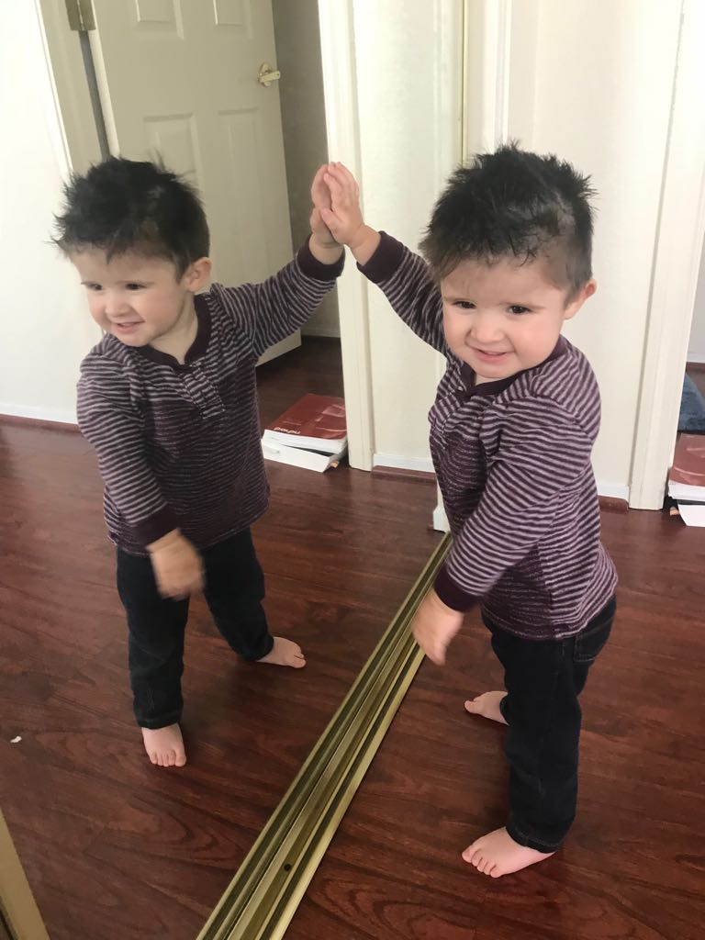
When Ethan was born, everything appeared to be fine, but then little by little, things began to pop up that suggested he might need some extra help. First, we discovered he had a heart murmur (caused by a small hole in his heart, a VSD). Then, his pediatrician noticed that he looked a bit floppy (hypotonic) and suggested we contact Nevada Early Intervention Services (NEIS). When Ethan began having seizures at 2 months old, we knew something was definitely wrong. After a hospital stay, tons of tests, including an MRI, CT, spinal tap, etc., we finally discovered, through genetic testing, that he is missing a tiny portion of his first chromosome. He was diagnosed with 1P36 Deletion Syndrome. 1P36 Deletion Syndrome is a rare disorder; no one was able to give us very much information on what to expect. Any information I was able to find online painted a grim picture.
We were unsure whether our little boy would ever be able to sit-up, crawl, walk, talk; feed himself, milestones that are often taken for granted. My greatest fear was that he would not even recognize us, his own parents. I was determined to access whatever services were available to help my baby. I called the NEIS number printed on a pamphlet provided by Ethan’s pediatrician. Soon after, Therapy Management Group (TMG) visited our home to evaluate Ethan, and the services began. Ethan was about 3 months old when we started with physical therapy to get him moving (he couldn’t hold his head up very well) and vision therapy (he wasn’t tracking and it was unclear how much he could see). As he grew, we added speech therapy and occupational therapy. Throughout the process, Ethan has had a team of professionals looking out for him, assessing him, tracking his progress, and, most importantly, teaching us, his family, how to work with him.
As a parent we often ask ourselves, “Am I doing enough to help my child develop?” As a parent of a child with special needs, it feels like that question has even more weight and is constantly present. Knowing that we are working with our early intervention team, and that we were able to get Ethan into early intervention so early on, I am confident that we are doing everything we can to help Ethan thrive. We are active in our child’s treatment, and we have a group of professionals available for guidance and support. We are not alone. We are not powerless.
Today, Ethan is almost two. He is a happy, sweet toddler, who loves cars, animals, and playing outside. He’s close to walking independently, is beginning to use sign language to communicate, and continues to learn, grow, and have fun. Time will tell to what extent the syndrome will affect him; for now, we take each day as it comes, setting the best foundation with the help of early intervention services and celebrating each new milestone, at Ethan’s own pace. Early Intervention has been amazing for Ethan and our family, and I would advise other parents to access services as early as possible.

